Auglagze Roughrider
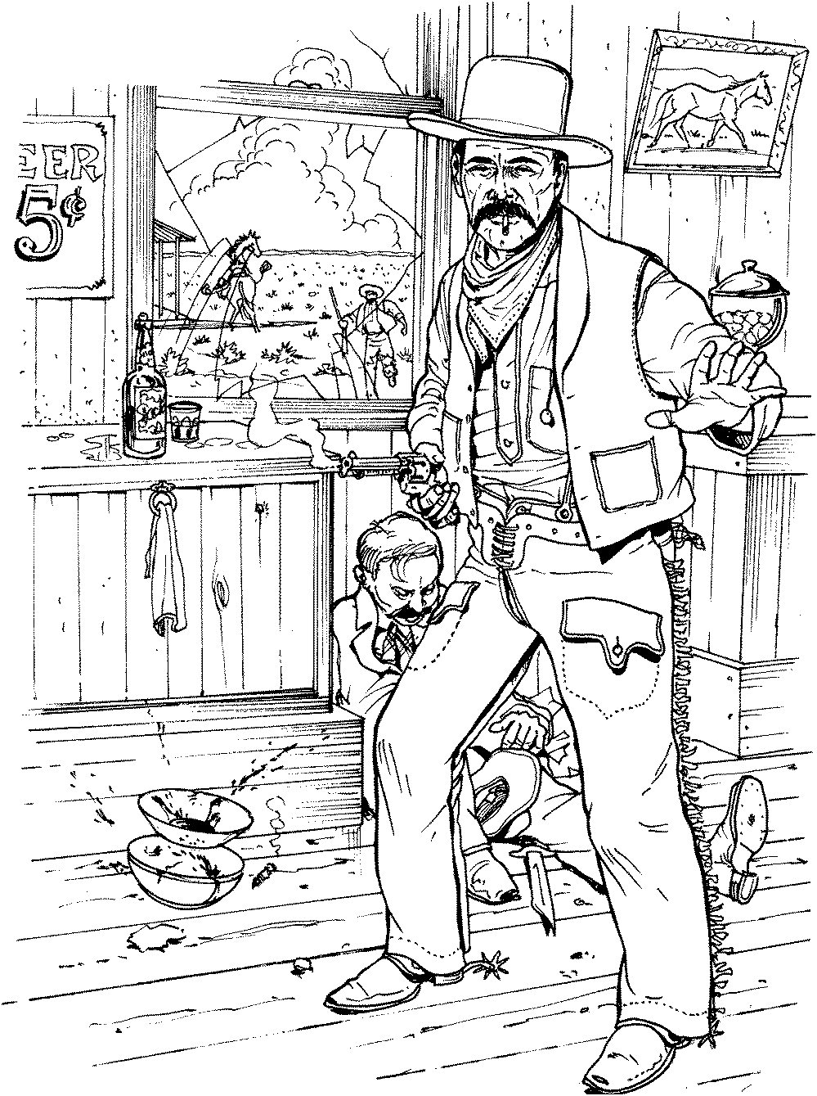

First Place
Ladies Silver Senior
Peachy the Score Keeper
5/19/2019

Auglagze Roughrider

First Place
Modern
Ranger Jim
5/19/2019

Auglagze Roughrider

First Place
Duelist
Moggy
5/19/2019

Auglagze Roughrider

First Place
Elder Statesman
Timekeeper
5/19/2019

Auglagze Roughrider

Second Place
Elder Statesman
Death Wind
5/19/2019

Auglagze Roughrider

Third Place
Elder Statesman
Andy
5/19/2019

Auglagze Roughrider

First Place
Traditional
Whip Lash Larue
5/19/2019

Auglagze Roughrider

Second Place
Traditional
Lloyd
5/19/2019

Auglagze Roughrider

Third Place
Traditional
Jack Panner
5/19/2019

Auglagze Roughrider

First Place
WB Modern
Wagon Thief
5/19/2019

Auglagze Roughrider

Second Place
WB Modern
Bear River Smith
5/19/2019

Auglagze Roughrider

Third Place
WB Modern
Padre P.W.
5/19/2019

