Rough Riders
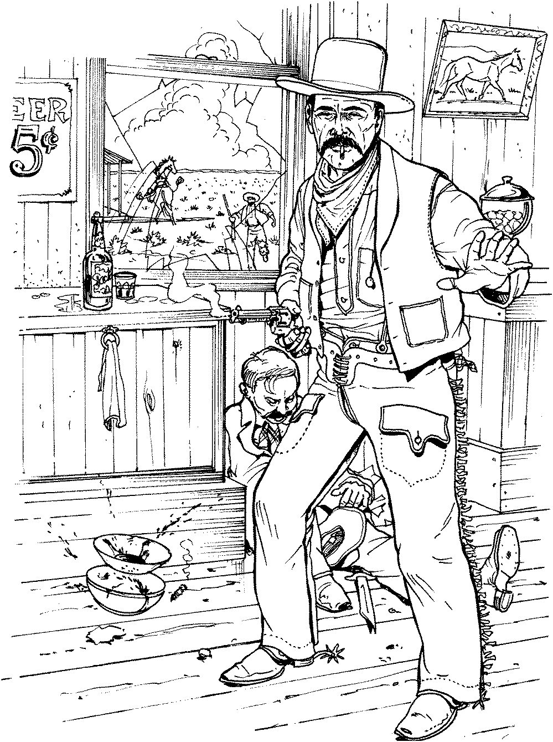

First Place
Modern
Grumpy
9/16/2018

Rough Riders

First Place
Ladies Silver Senior
Peachy the Score Keeper
9/16/2018

Rough Riders

Second Place
Modern
Ranger Jim
9/16/2018

Rough Riders

First Place
Elder Statesman
Timekeeper
9/16/2018

Rough Riders

Second Place
Elder Statesman
Death Wind
9/16/2018

Rough Riders

Third Place
Elder Statesman
Andy
9/16/2018

Rough Riders

First Place
Traditional
Whip Lash Larue
9/16/2018

Rough Riders

Second Place
Traditional
Bad John
9/16/2018

Rough Riders

First Place
Ladies Wrangler
Redhead
9/16/2018

Rough Riders

First Place
WB Modern
Chemistry Kid
9/16/2018

Rough Riders

Second Place
WB Modern
Bear River Smith
9/16/2018

Rough Riders

Third Place
WB Modern
Wagon Thief
9/16/2018

