Roughriders
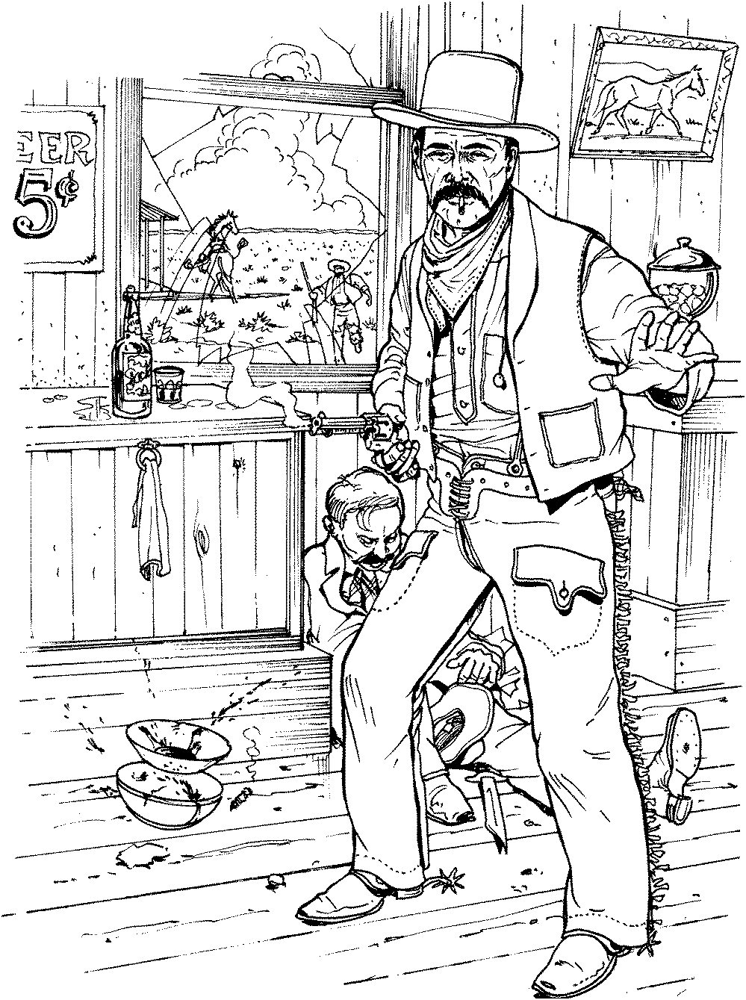

First Place
Ladies Silver Senior
Peachy the Score Keeper
5/20/2018

Roughriders

First Place
CattleBaron
Darby
5/20/2018

Roughriders

First Place
Modern
Grumpy
5/20/2018

Roughriders

Second Place
Modern
Ranger Jim
5/20/2018

Roughriders

First Place
Cowboy
Timekeeper
5/20/2018

Roughriders

First Place
Senior
Ironton
5/20/2018

Roughriders

Second Place
Senior
Andy
5/20/2018

Roughriders

First Place
Traditional
Cross Dogwood
5/20/2018

Roughriders

Second Place
Traditional
Bad John
5/20/2018

Roughriders

First Place
WB Modern
Padre P.W.
5/20/2018

Roughriders

Second Place
WB Modern
Jack Panner
5/20/2018

Roughriders

Third Place
WB Modern
Death Wind
5/20/2018

Roughriders

Fourth Place
WB Modern
Bear River Smith
5/20/2018

Roughriders

Fifth Place
WB Modern
Wagon Thief
5/20/2018

