Rough Riders
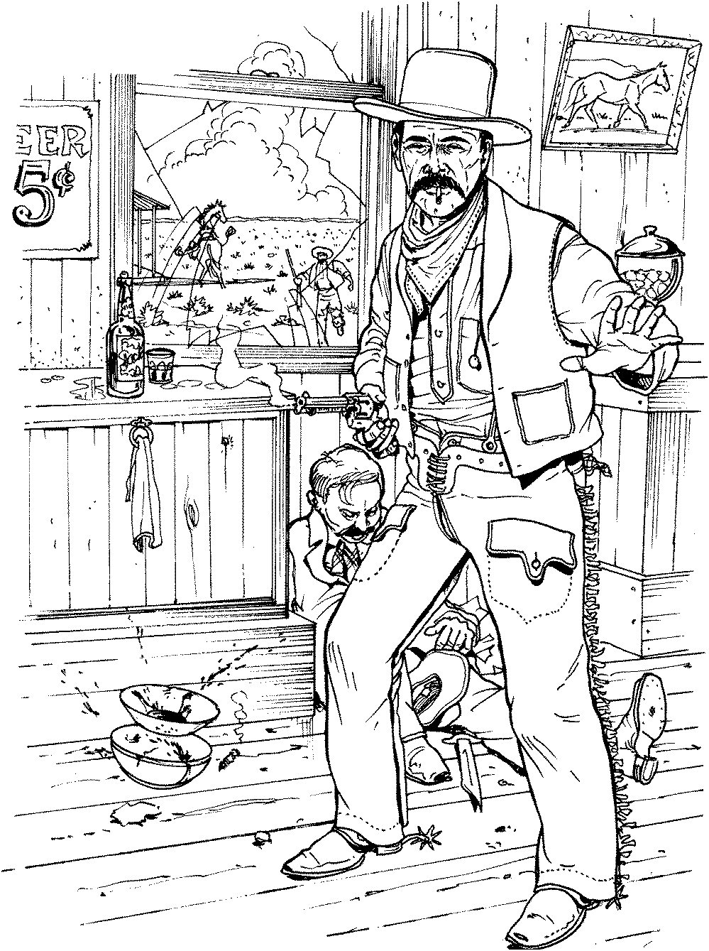

First Place
Modern
Grumpy
8/19/2018

Rough Riders

First Place
Ladies Silver Senior
Peachy the Score Keeper
8/19/2018

Rough Riders

First Place
Elder Statesman
Timekeeper
8/19/2018

Rough Riders

Second Place
Elder Statesman
Andy
8/19/2018

Rough Riders

First Place
Traditional
Whip Lash Larue
8/19/2018

Rough Riders

First Place
Ladies Wrangler
Redhead
8/19/2018

Rough Riders

First Place
WB Modern
Jack Panner
8/19/2018

Rough Riders

Second Place
WB Modern
Padre P.W.
8/19/2018

Rough Riders

Third Place
WB Modern
Chemistry Kid
8/19/2018

Rough Riders

Fourth Place
WB Modern
Wagon Thief
8/19/2018

Rough Riders

Fifth Place
WB Modern
Bear River Smith
8/19/2018

